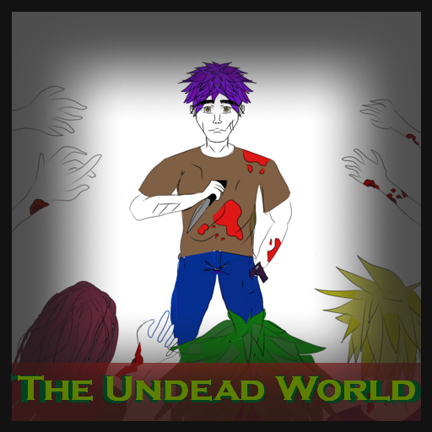

**Will you survive**

**the new reality of this world?**

**Developers:**

Tracey Vergara  
Valentin Georgiev  
Denmar Ermitano

**Revision Date:**

November 13, 2020

**Executive Summary**

The game is a platformer shooter, where the player tries to find safety in a zombie-ridden world. The world is going through a zombie apocalypse. The zombies want to turn all humans in the area into their own kind and eventually conquer the world.

The world is divided into 4 main sections in the game: the hospital, the streets, the forest, and the beach. The player travels throughout all these areas to finally reach a sailboat, where they can sail off into the distance for safety. All around the different levels, useful items can be found, such as a new, stronger weapon or a healing item in case the player has taken damage in a zombie encounter. Small details in the map are scattered to add a bit of life and make the map just a bit more attractive.

The main character, the player, worked as a trainer, and is therefore in good shape. He does not have that many friends or family, working as a lone wolf in the world. He wears a simple brown shirt and jeans. He lives in the US and has been preparing all his life for an apocalypse and knows very well how to use guns. He always carries his knife to be sure that he can defend himself in any situation. He is the perfect fit for a zombie game, as he has the instinct and physicality to stand up against the zombies. He had the motivation to survive and put his skills to use, putting down as many zombies as possible.

The enemies stopping the main character are the zombies, present in every level. At the start of the game, the zombies will be easier to kill. As the game progresses, the zombies will get stronger and stronger, shown by the darkness of their color (the darker, the harder it is to kill). In this world, a virus has contaminated a big amount of the population and turned people into zombies. They walk mindlessly and their only goal is to attack and bite other humans to turn them into zombie. Zombies are covered in blood and are green.

The most prominent game mechanics are health, gravity, and shooting.

The health bar is slowly chipped away when a zombie comes too close to the player, resulting in damage. When the health bar reaches 0, the player is given the choice to restart the level. Items scattered around the world are used to replenish health.   
Gravity is present in the game to allow the player to jump around in places. This allows for another level of difficulty. The player is rewarded with items once they reach harder to get places.  
Shooting is the main form of combat. To avoid taking damage from zombies, the player can kill the zombies by shooting at them, utilizing their weapon. Different weapons throughout the game can be acquired, dealing more damage per second.

In order to beat the game, the player will have to survive every level until the last one, shooting zombies in their way. Parkour is a challenge offered on top of the fact that the zombies are out for your blood. The player will have the keep their health up while progressing in the game. They have to get as much damage as they can before the zombies get to them in their adventure.

**Player Composite**  
Jacob Williams, 14, High School student in eighth grade. He is a casual gamer who plays 1 – 2 hours of video games per day. His favorite types of games are shooters and platformers, and he plays a lot of Super Mario Bros. He plays on the Nintendo Switch mainly in his room, mostly single player games. He plays basketball and enjoys shows like “The Walking Dead” and other similar horror movies.  **User Interface Mock-ups**

Flow Chart

Street Area  
 Level 2: Downtown

Hospital Area  
 Level 1: Floors

Forest Area  
 Level 3: Meadow

Beach Area  
 Level 4: Shore

Every level has the same basic goal: kill the zombies and reach the next colored door to progress in the quest to find safety. They will progress in a very linear fashion. You cannot access a past level once you exit through its door. The different areas are there to split up the styles between the levels instead of having 1 monotone style, while still staying in the same world.

Level designs

The 4 levels are comprised of a floor, various objects to jump on and zombies to avoid or kill (represented by green 2x1 rectangles).   
  
The first level starts at the bed, while the others start from the right side. Each level ends once the player reaches the door lined in yellow for visibility.   
  
Each level offers a new challenge or a new combination of challenges.

Level 1: Hospital

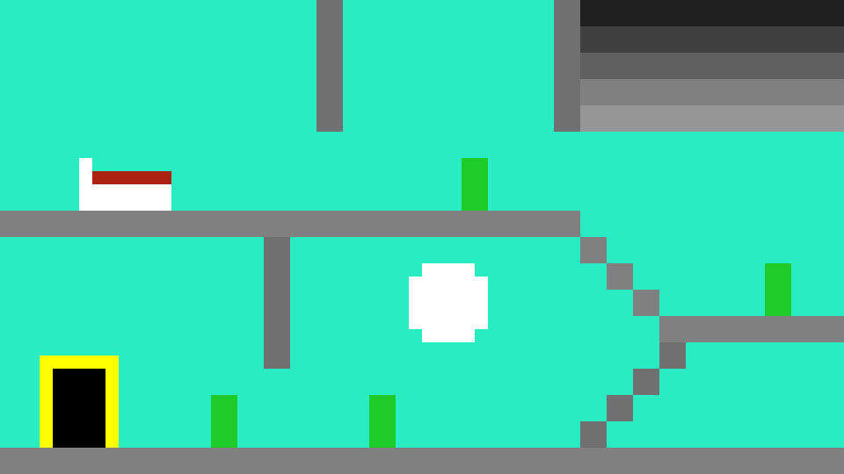  
  
This is the “tutorial level”. There are two floors to this level and a few separated zombies. This is where the player can learn and get used to the controls without much worry. There is not much difficult maneuvering to do in this level, nor much of a challenge with the number of zombies.

Level 2: Downtown

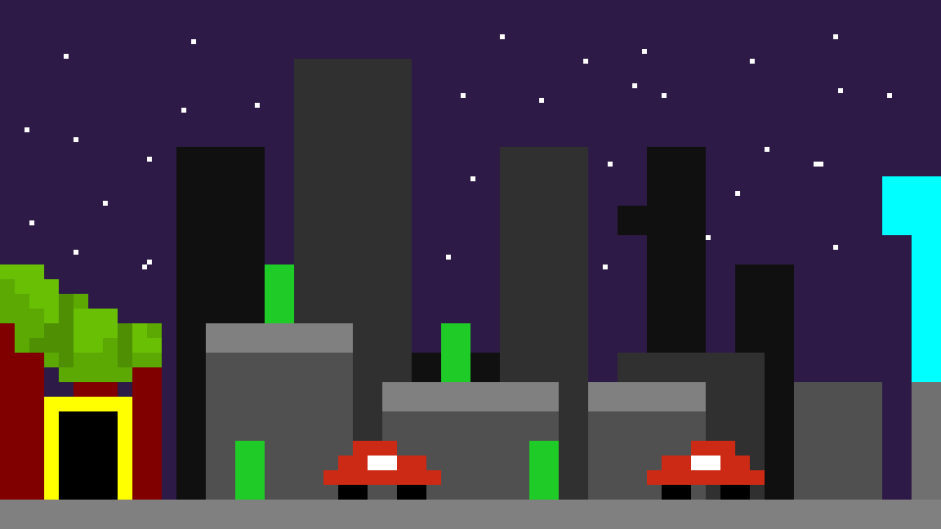

This level offers cars as objects to jump on and allows the player to reach the roofs. Items can be placed on the top of those, rewarding the player. More isolated zombies are present in this level, in exchange for a more parkour-style challenge.

Level 3:

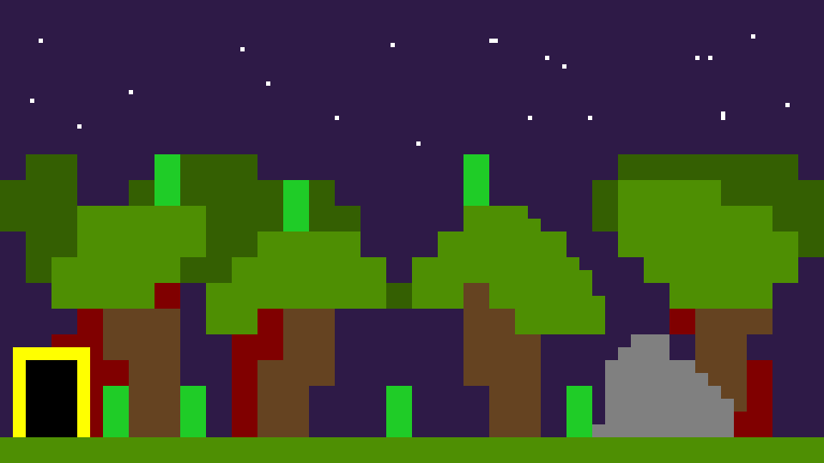

This level combines the two previous levels. On top of the ground, there is another platform to kill the zombies, the treetops. The player makes use of the rock to get on top. When on the ground, they face more zombies in a flat area, while the treetops offer less space with less zombies.

Level 4:

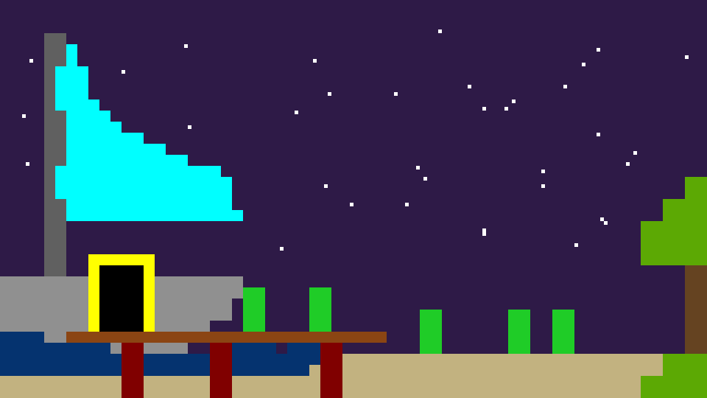After one of the more stressful levels, the player has a fairly simple ending. A good number of zombies decently close to each other offers a good challenge to the player while giving them enough slack after the last level. After reaching the door by the sailboat, the player goes to the ending screen.

World Transitions

Before each world, the player is presented with a transitional screen, just to give them time to recollect themselves and not to be put under constant stress. They simply show the corresponding area.

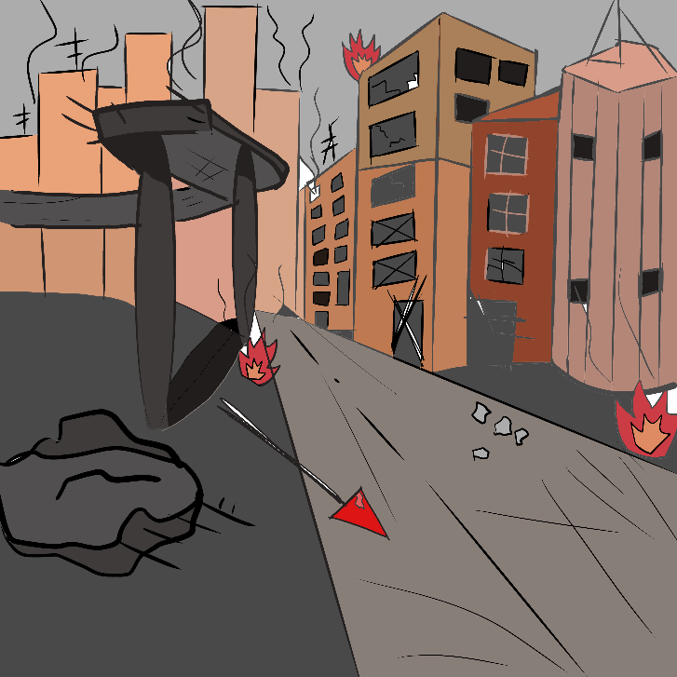

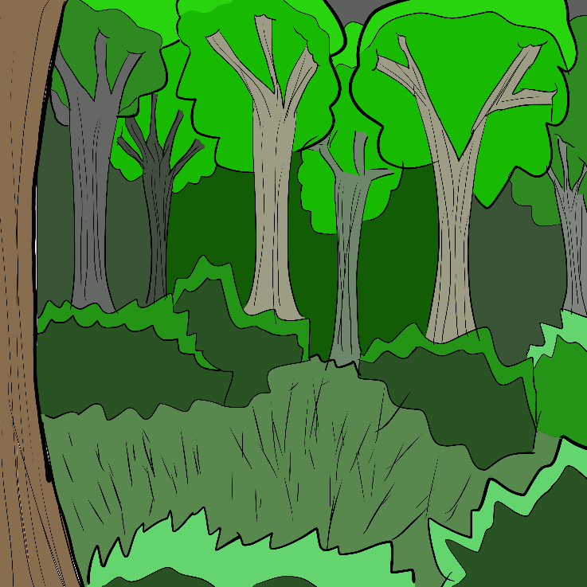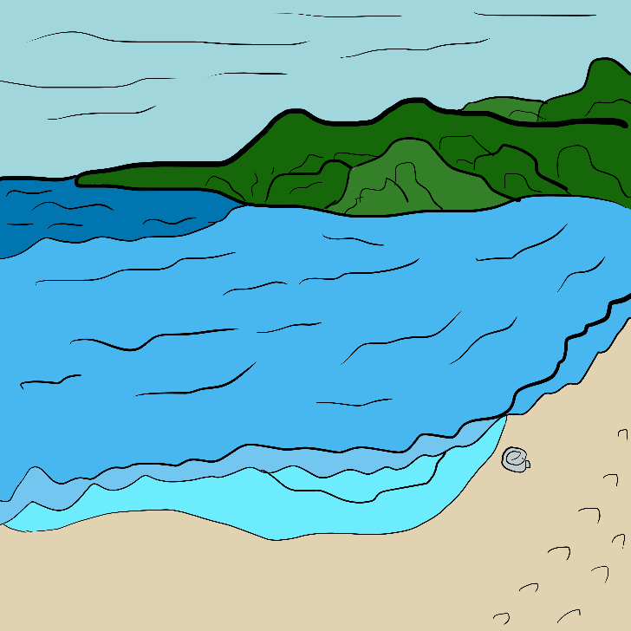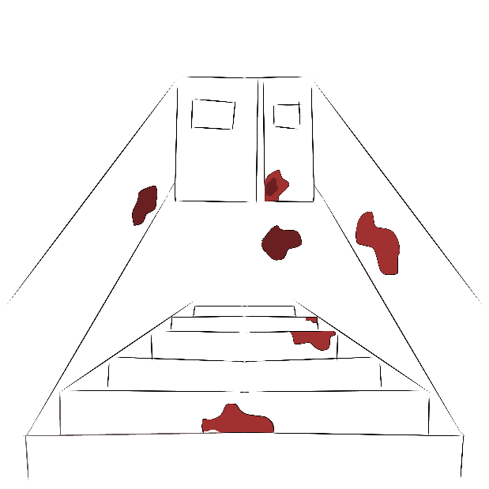

Beach

Forest

Streets

Hospital

Start Screen

**Press spacebar to**

This is the screen that shows near the start of the game.

Game Over Screen

Once the player’s health reaches 0, the game over screen appears. It allows the player to try the level once more.

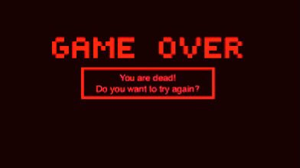**Controls**

Basic movement

W - to jump upwards  
 A - to move to the left of the map  
 S - to duck, dodge a projectile  
 D - to move to the right of the map

Object interaction

E - to interact with an object  
 (go through a door, use a health item)

Combat Related

Spacebar - to shoot the equipped gun

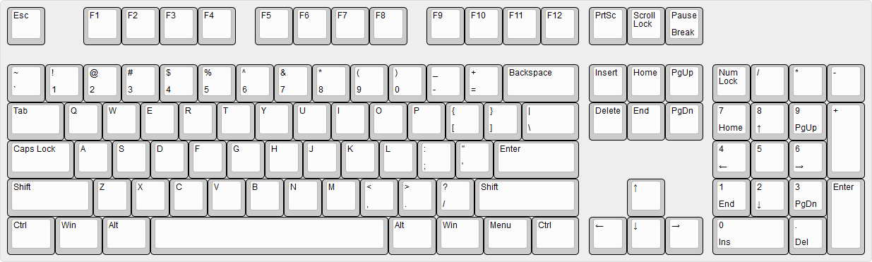

WASD: Basic movement

Spacebar: Shoot Weapon

E: Object Interaction

**Schedule & Related Elements**

Implementing the different worlds, the map  
 Members: Tracey, Denmar  
 Deadline: November 17  
  
Inputting the objects and the player model with movement  
 Members: Denmar, Valentin  
 Deadline: November 19  
  
Implementing the different weapons and items  
 Members: Valentin, Tracey  
 Deadline: November 20  
  
Inputting the enemies and their movement  
 Members: Valentin, Denmar  
 Deadline: November 22  
  
Write the dialogue/text to guide the player  
 Members: Valentin, Tracey  
 Deadline: November 22  
  
Adding soundtrack  
 Members: The whole team (Valentin, Tracey, Denmar)  
 Deadline: November 24  
  
Adding sound effects and feedback sounds (jumping, shooting)  
 Members: Tracey, Denmar  
 Deadline: November 24  
  
Finishing touches (debugging, refining)  
 Members: The whole team (Denmar, Valentin, Tracey)  
 Deadline: November 26